|  |
| --- |
| Name: Trần Quang Khải  ID:21520955  Class: IT007.N11.KHCL |

OPERATING SYSTEM  
LAB 4 Prepare

**SUMMARY**

|  |  |  |  |
| --- | --- | --- | --- |
| **Task** | | **Status** | **Page** |
| 4.5 | 4 | Done | 2,3,4 |

**Self-scrores: 95**

*\*Note: Export file to* ***PDF*** *and name the file by following format:* ***LAB X – <Student ID>.pdf***

4.5.3

Mô phỏng giải thuật Round Robin

Code: <https://github.com/TQKhai3002/Lab4>

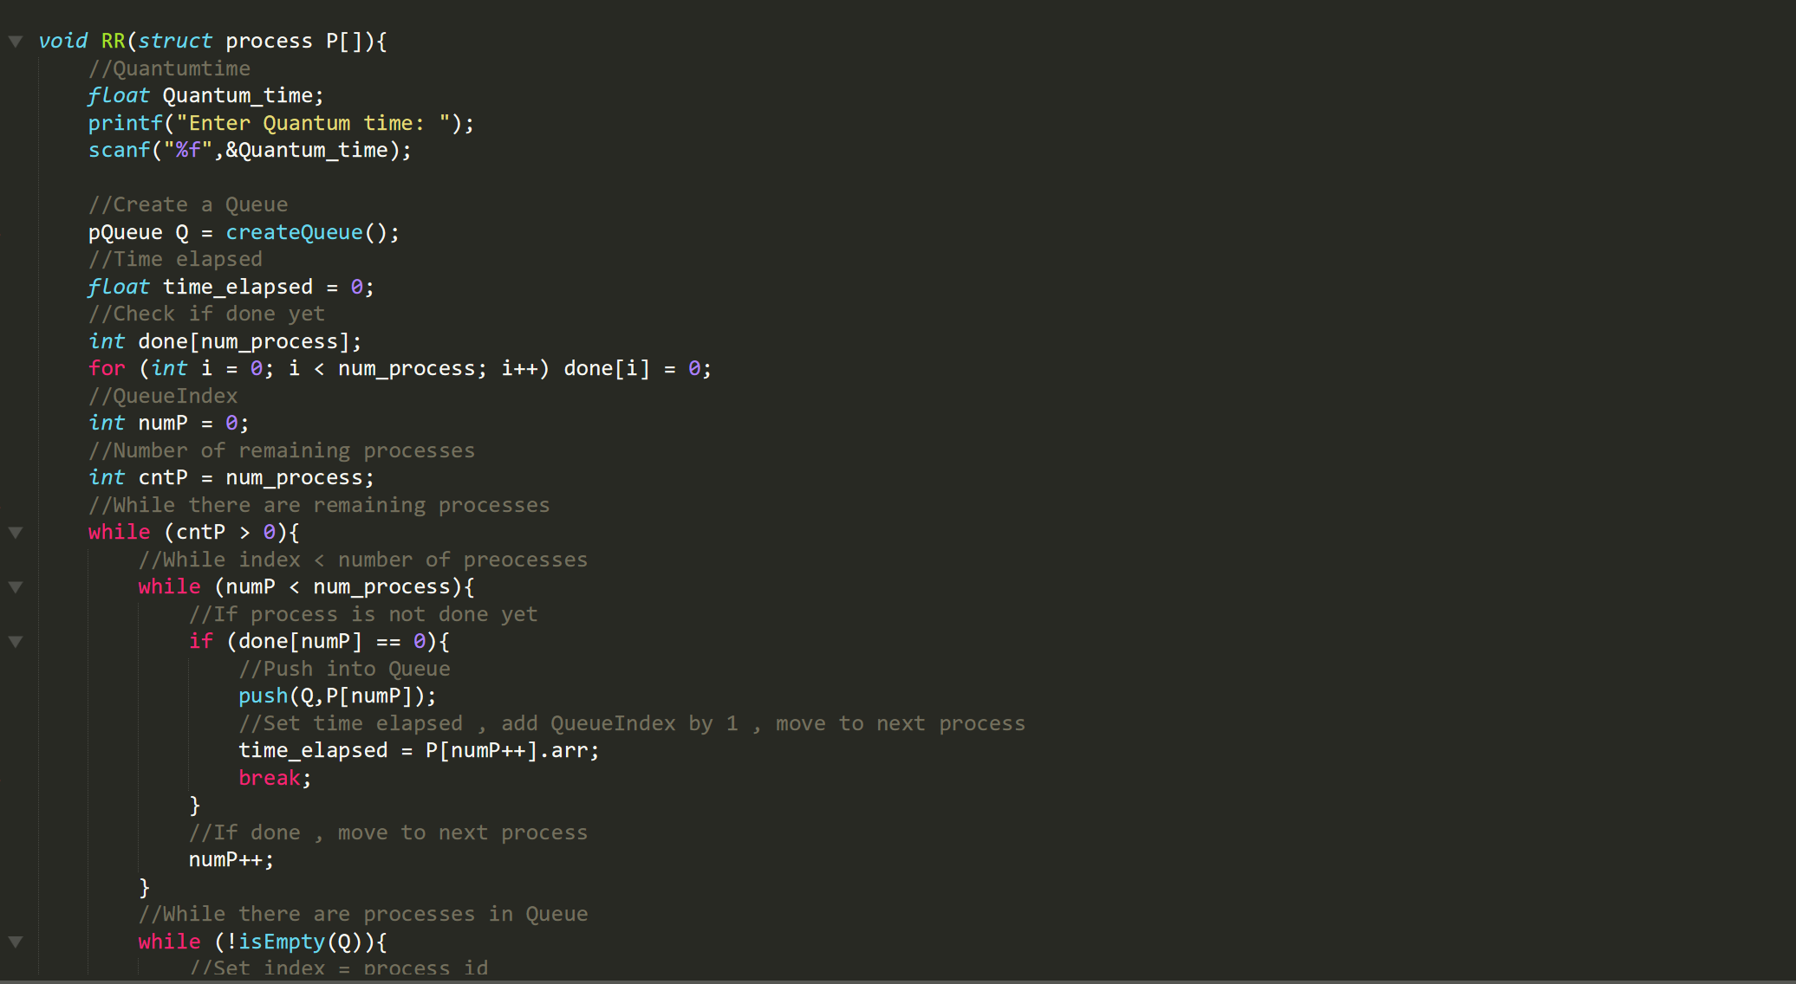

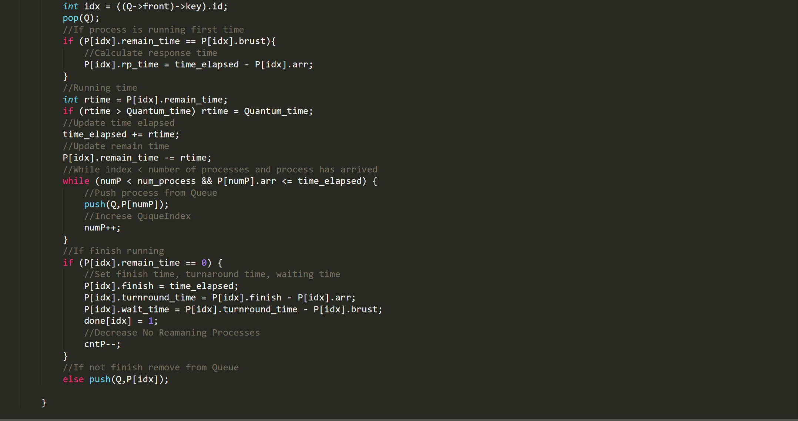

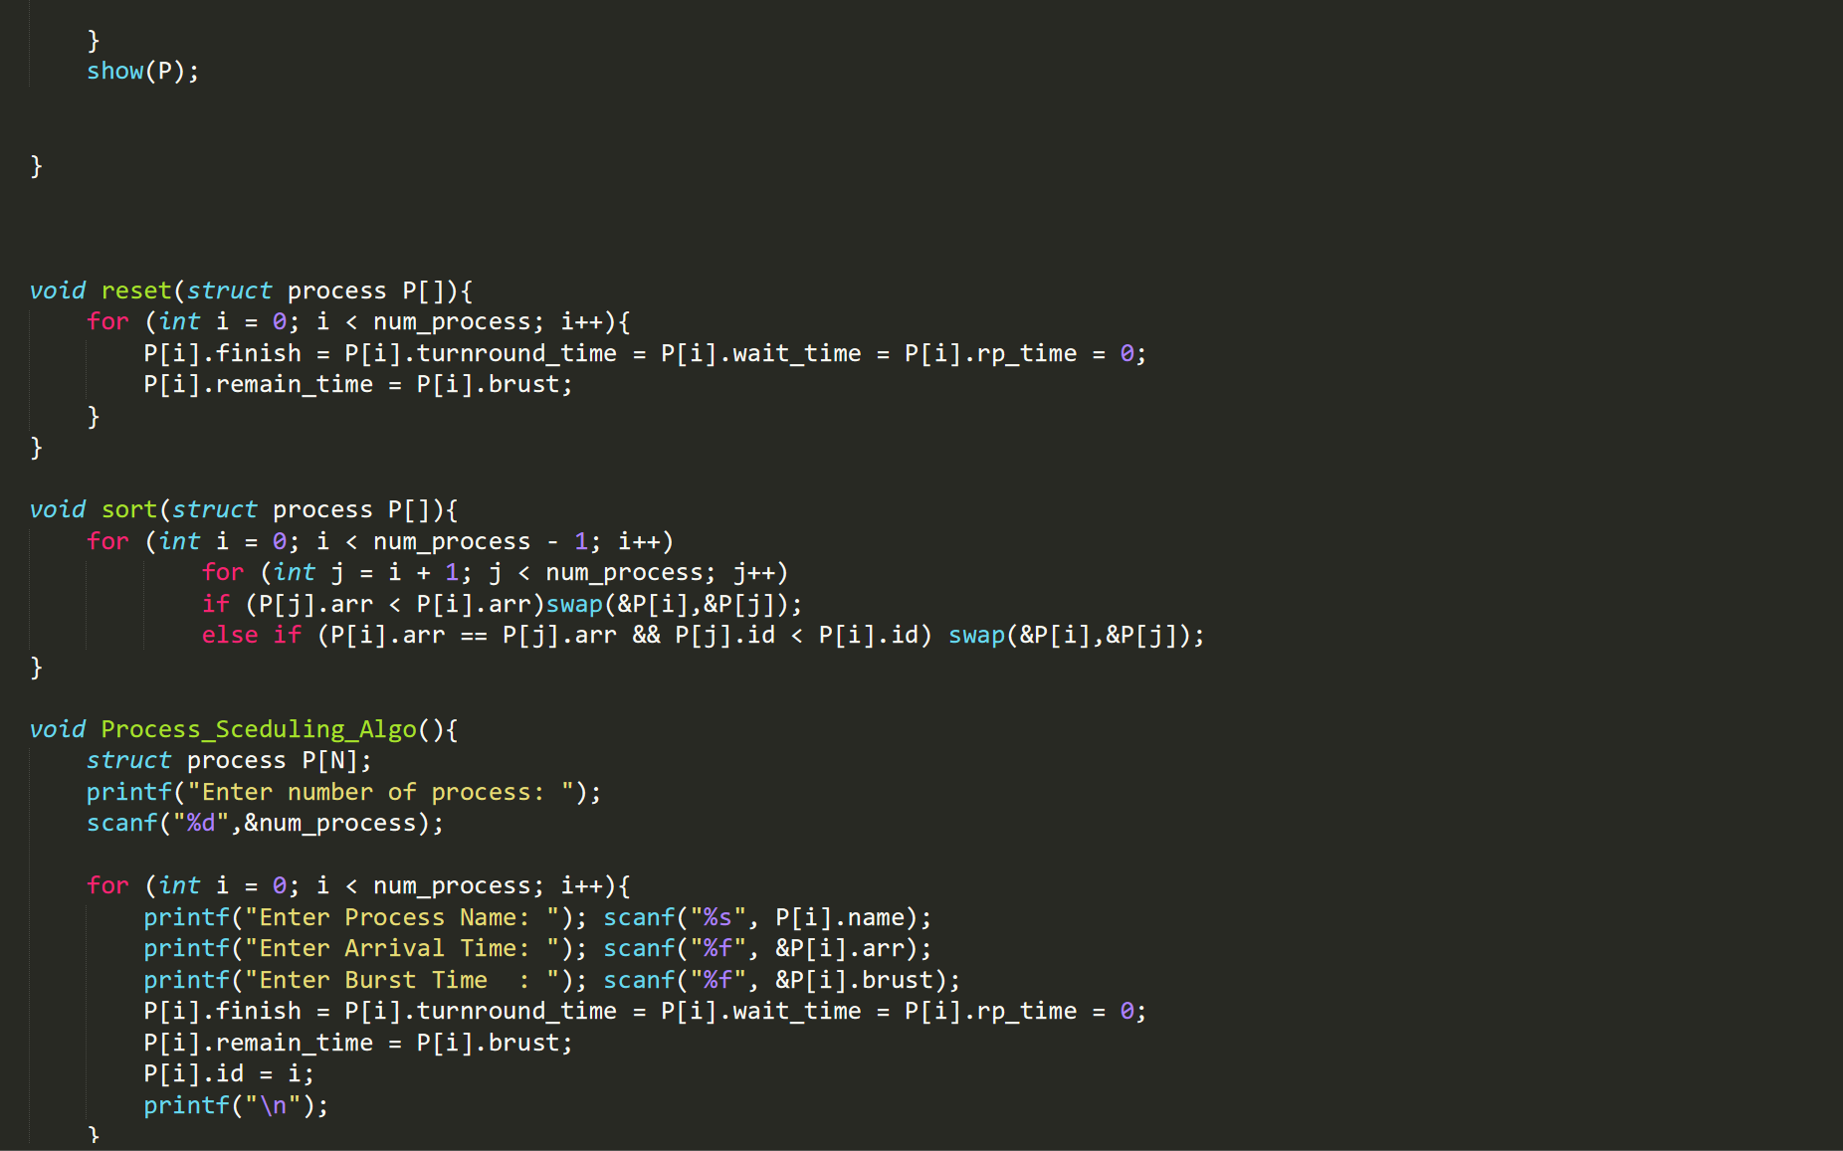

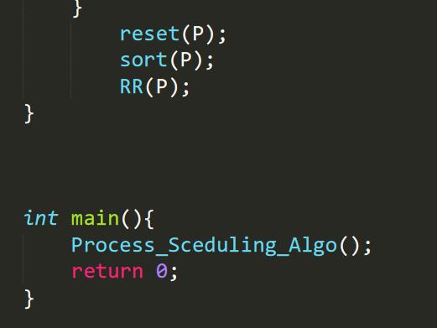

Input:

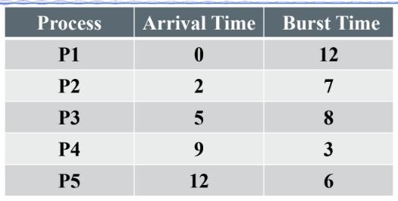

Output:

